Instructions to set up the data base:

- Create a Database and call it ChannelAssist_BankDB

- Run the SQL Query **it will initial add data as well.**

To See the list of Accounts and their balance run: GetAllAccountsBalance

To search an account by FirstName/ last name or FirsName LastName run: GetAccountBalanceByName

Each Stored procedure has a short description with a sample params to run

**Implementation**

We have a Bank Account the value of bank is always negative and is equal to sum of all the other accounts. Bank Takes the money from Customers and it becomes negative as much as it’s taken.

Here **-30 + 10 + 20 = 0** This is an even balance; Banks close their account at the end of each day if this is zero. I’ve initialized with some sample data.

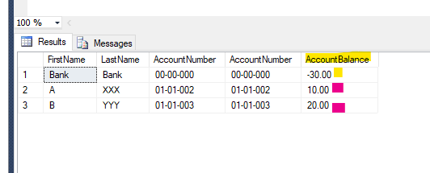

Stored procedure to transfer funds between to accounts: InsTransferBillingAmmount

Example: Exec InsTransferBillingAmmount 3,8, 2,2, 5.25, 2,'Transfer From B to A $5.25'

It Transfer funds , you can keep running it till you get the error. I wrote a scalar function to check the balance.

**FROM** Customer 3 of their account number 8

**TO** Customer 2 to their Account ID: 2

**Amount**: $5.25

**Transaction Type**: 2

*Also has a Comment (Adds it automatically.) to reset data delete every thing that does not start with Deposit or withdraw from* BillingTransaction

Each Transaction has two records:

+ Billing Amount Deposited to the Destination Account

- Billing Amount Withdrawn from the Source Account

IF it can Transfer will show the overall balance of all (I put it this way to make it easier to review) The Balanced condition with **Bank** is true still.

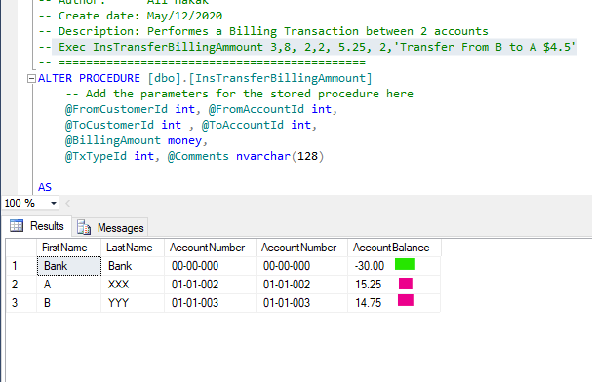

IF you request to transfer more than remaining balance it raises below error:

